Trajectory

Definition
# Source: AI Source: Provided by: [Data Path: Persons Table -> ID Column: 1, Name_En Column: Motasem Essam] -> From: [ChatGPT] on [7/25/2026]
A trajectory is the curve or path traced by a moving point, object, or particle as it changes position over time.
$$\boxed{\text{Trajectory}=\text{The geometric path of a moving object}}$$
A trajectory describes where an object moves, while time describes when it is at each position.
For a moving point represented by
$$P\left(t\right)=\left(x , \left(t\right)y\left(t\right)\right),$$
the set of positions occupied by $P$as $t$varies forms its trajectory.

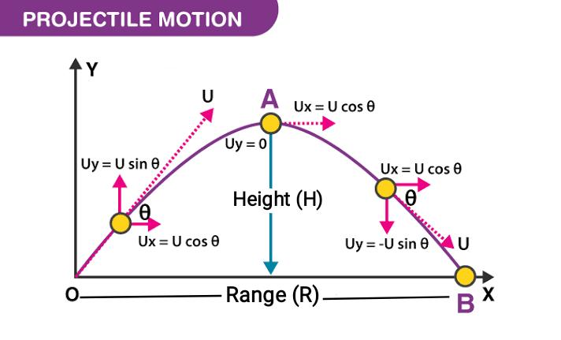
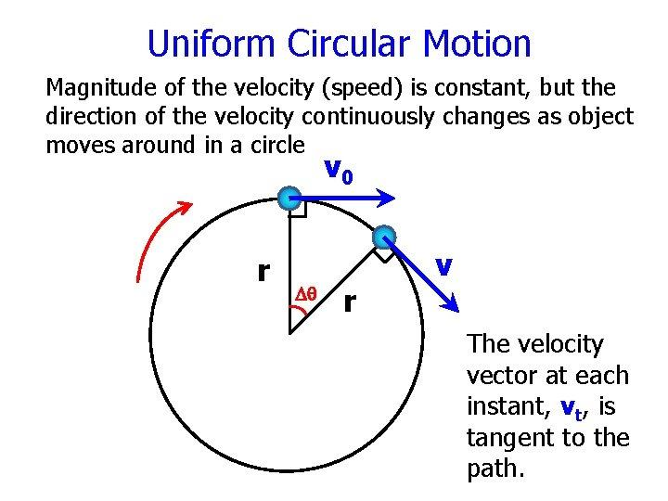
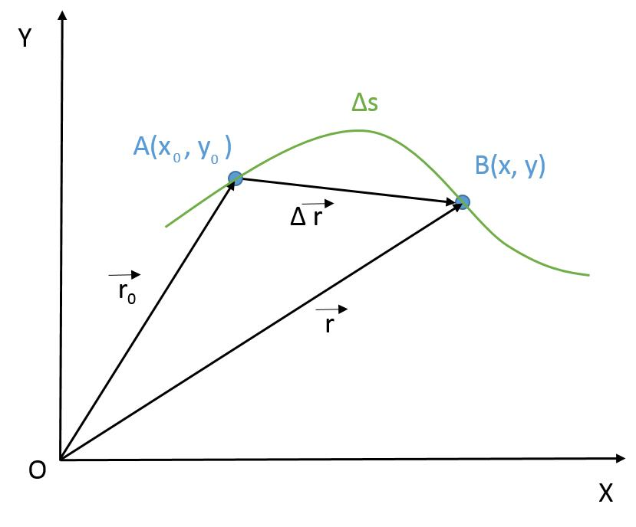
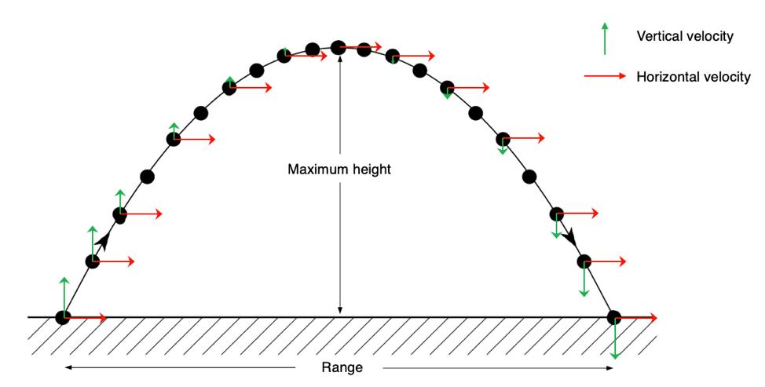
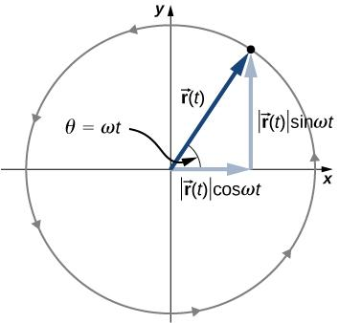

Simple Definition
# Source: AI Source: Provided by: [Data Path: Persons Table -> ID Column: 1, Name_En Column: Motasem Essam] -> From: [ChatGPT] on [7/25/2026]
A trajectory is the path followed by a moving object.
Example
When a ball is thrown through the air, ignoring air resistance, its trajectory is approximately a parabola.
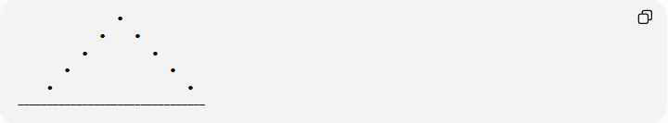
●
● ●
● ●
● ●
● ●
────────────────────────────────
The ball's changing position creates the trajectory.

Fundamental Concept
# Source: AI Source: Provided by: [Data Path: Persons Table -> ID Column: 1, Name_En Column: Motasem Essam] -> From: [ChatGPT] on [7/25/2026]
A trajectory connects position and time:
$$\boxed{\text{Time}→\text{Position}→\text{Trajectory}}$$
A trajectory can be represented parametrically:
$$\boxed{P\left(t\right)=\left(x , \left(t\right)y\left(t\right)\right)}$$
where:
- $t$= time or another parameter
- $x\left(t\right)$= horizontal position
- $y\left(t\right)$= vertical position
- $P\left(t\right)$= position at time $t$
The trajectory is obtained by considering all positions:
$$\left\{P\left(t\right):t∈I\right\}.$$

Main Types of Trajectories
# Source: AI Source: Provided by: [Data Path: Persons Table -> ID Column: 1, Name_En Column: Motasem Essam] -> From: [ChatGPT] on [7/25/2026]
A practical classification is:
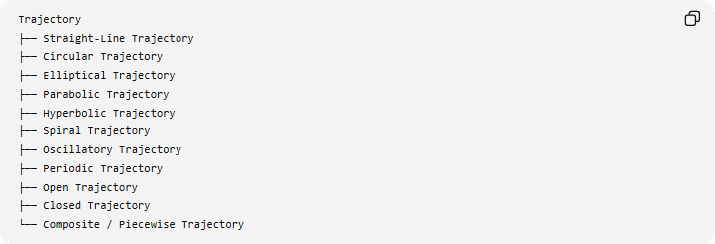
Trajectory
├── Straight-Line Trajectory
├── Circular Trajectory
├── Elliptical Trajectory
├── Parabolic Trajectory
├── Hyperbolic Trajectory
├── Spiral Trajectory
├── Oscillatory Trajectory
├── Periodic Trajectory
├── Open Trajectory
├── Closed Trajectory
└── Composite / Piecewise Trajectory
These categories can overlap. For example, a circular trajectory is both closed and periodic.

Straight-Line Trajectory
# Source: AI Source: Provided by: [Data Path: Persons Table -> ID Column: 1, Name_En Column: Motasem Essam] -> From: [ChatGPT] on [7/25/2026]
Definition
A straight-line trajectory occurs when a moving object follows a straight line.
$$P\left(t\right)=P_{0}+t\vec{v}$$
where:
- $P_{0}$is the initial position,
- $\vec{v}$is a constant velocity vector.
Example
If
$$P\left(t\right)=\left(2 , +3t 1+2t\right),$$
then the object moves along a straight line.
Eliminating $t$:
$$x=2+3t \\ y=1+2t$$
gives
$$y=1+\frac{2}{3}\left(x-2\right).$$
Thus, the trajectory is a straight line.

Circular Trajectory
# Source: AI Source: Provided by: [Data Path: Persons Table -> ID Column: 1, Name_En Column: Motasem Essam] -> From: [ChatGPT] on [7/25/2026]
Definition
A circular trajectory occurs when an object moves around a circle.
$$P\left(t\right)=\left(h , +r\cos{t} k+r\sin{t}\right).$$
The trajectory satisfies:
$${\left(x-h\right)}^{2}+{\left(y-k\right)}^{2}=r^{2}.$$
Example
An object moving around a circular track of radius $10$has:
$$P\left(t\right)=\left(10 , \cos{t}10\sin{t}\right).$$
Its trajectory is the circle
$$x^{2}+y^{2}=100.$$
Applications
- circular tracks
- rotating objects
- points on rotating wheels
- idealized orbital motion

Elliptical Trajectory
# Source: AI Source: Provided by: [Data Path: Persons Table -> ID Column: 1, Name_En Column: Motasem Essam] -> From: [ChatGPT] on [7/25/2026]
Definition
An elliptical trajectory follows an ellipse.
For example:
$$\frac{x^{2}}{a^{2}}+\frac{y^{2}}{b^{2}}=1.$$
A parametric representation is:
$$P\left(t\right)=\left(a , \cos{t}b\sin{t}\right).$$
Example
If
$$a=5, b=3,$$
then:
$$P\left(t\right)=\left(5 , \cos{t}3\sin{t}\right).$$
The trajectory is
$$\frac{x^{2}}{25}+\frac{y^{2}}{9}=1.$$

Parabolic Trajectory
# Source: AI Source: Provided by: [Data Path: Persons Table -> ID Column: 1, Name_En Column: Motasem Essam] -> From: [ChatGPT] on [7/25/2026]
Definition
A parabolic trajectory follows a parabola.
A general vertical parabola can be represented as:
$$y=ax^{2}+bx+c.$$
Example: Projectile Motion
Ignoring air resistance, a projectile launched near Earth's surface can have an idealized trajectory:
$$y=-\frac{g}{2v_{0}^{2}\cos^{2}θ}x^{2}+x\tan{θ}+h.$$
The resulting trajectory is parabolic.
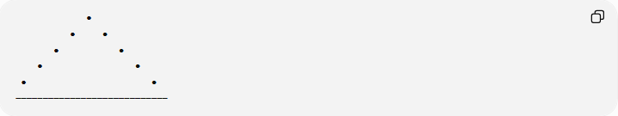
●
● ●
● ●
● ●
● ●
────────────────────────────
This is one of the most familiar physical examples of a trajectory.

Hyperbolic Trajectory
# Source: AI Source: Provided by: [Data Path: Persons Table -> ID Column: 1, Name_En Column: Motasem Essam] -> From: [ChatGPT] on [7/25/2026]
Definition
A hyperbolic trajectory follows a hyperbola.
For example:
$$\frac{x^{2}}{a^{2}}-\frac{y^{2}}{b^{2}}=1.$$
In orbital mechanics, an object with sufficient energy can follow an idealized hyperbolic escape or flyby trajectory relative to a central body.
Example
A hyperbolic path can be represented by:
$$\frac{x^{2}}{25}-\frac{y^{2}}{16}=1.$$
The moving object follows one branch of the hyperbola.

Spiral Trajectory
# Source: AI Source: Provided by: [Data Path: Persons Table -> ID Column: 1, Name_En Column: Motasem Essam] -> From: [ChatGPT] on [7/25/2026]
Definition
A spiral trajectory occurs when a moving point rotates around a center while its distance from the center changes.
In polar coordinates:
$$r=f\left(θ\right).$$
Example
An Archimedean spiral:
$$\boxed{r=a+bθ}$$
produces a trajectory whose distance from the center increases linearly with the angle.

╭────╮
╭─╯ ╰─╮
│ ● │
╰╮ ╭─╯
╰──────╯

Oscillatory Trajectory
# Source: AI Source: Provided by: [Data Path: Persons Table -> ID Column: 1, Name_En Column: Motasem Essam] -> From: [ChatGPT] on [7/25/2026]
Definition
An oscillatory trajectory repeatedly moves back and forth or varies around an equilibrium position.
A simple example is:
$$x\left(t\right)=Acos⁡\left(ωt\right).$$
Example
A point attached to an ideal spring can move according to:
$$x\left(t\right)=2cos⁡\left(3t\right).$$
The point repeatedly moves between:
$$x=-2$$
and
$$x=2.$$
Its motion is oscillatory.

Periodic Trajectory
# Source: AI Source: Provided by: [Data Path: Persons Table -> ID Column: 1, Name_En Column: Motasem Essam] -> From: [ChatGPT] on [7/25/2026]
Definition
A periodic trajectory repeats after a fixed time interval $T$.
$$\boxed{P\left(t+T\right)=P\left(t\right)}$$
where $T$is the period.
Example
Circular motion:
$$P\left(t\right)=\left(r , \cos{ω}tr\sin{ω}t\right)$$
has period
$$\boxed{T=\frac{2π}{ω}}.$$
After every $T$units of time, the object returns to the same position.

Open Trajectory
# Source: AI Source: Provided by: [Data Path: Persons Table -> ID Column: 1, Name_En Column: Motasem Essam] -> From: [ChatGPT] on [7/25/2026]
Definition
An open trajectory does not return to its starting point during the interval being considered.
Example
An object moving along:
$$P\left(t\right)=\left(t , t^{2}\right), t≥0$$
continues along a parabolic trajectory without forming a closed loop.

Closed Trajectory
# Source: AI Source: Provided by: [Data Path: Persons Table -> ID Column: 1, Name_En Column: Motasem Essam] -> From: [ChatGPT] on [7/25/2026]
Definition
A closed trajectory returns to its starting position.
If:
$$P\left(t_{0}\right)=P\left(t_{1}\right)$$
for $t_{1}>t_{0}$, the trajectory over that interval is closed.
Example
Circular motion:
$$P\left(t\right)=\left(r , \cos{t}r\sin{t}\right), 0≤t≤2π$$
satisfies:
$$P\left(0\right)=P\left(2π\right).$$
Therefore, the trajectory is closed.

Composite or Piecewise Trajectory
# Source: AI Source: Provided by: [Data Path: Persons Table -> ID Column: 1, Name_En Column: Motasem Essam] -> From: [ChatGPT] on [7/25/2026]
Definition
A composite trajectory consists of multiple sections having different forms.
For example:
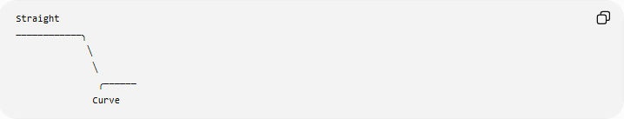
Straight
────────────╮
╲
╲
╭──────
Curve
Mathematically:
$$P\left(t\right)=\left\{\begin{matrix}P_{1}\left(t\right), & t_{0}≤t<t_{1} \\ P_{2}\left(t\right), & t_{1}≤t<t_{2} \\ P_{3}\left(t\right), & t_{2}≤t≤t_{3}\end{matrix}\right.$$
Example
A vehicle may:
- travel along a straight road,
- turn along a circular curve,
- continue along another straight road.
The complete route is a composite trajectory.

Trajectory in Coordinate Geometry
# Source: AI Source: Provided by: [Data Path: Persons Table -> ID Column: 1, Name_En Column: Motasem Essam] -> From: [ChatGPT] on [7/25/2026]
A trajectory can be described using different mathematical representations.
Cartesian Form
$$\boxed{F\left(x , y\right)=0}$$
Example:
$$y=x^{2}.$$
Parametric Form
$$\boxed{x=x\left(t\right), y=y\left(t\right)}$$
Example:
$$x=t, y=t^{2}.$$
Vector Form
$$\boxed{\vec{r}\left(t\right)=x\left(t\right)i+y\left(t\right)j}$$
Example:
$$\vec{r}\left(t\right)=ti+t^{2}j.$$
Polar Form
$$\boxed{r=f\left(θ\right)}$$
Example:
$$r=2θ.$$

Trajectory and Velocity
# Source: AI Source: Provided by: [Data Path: Persons Table -> ID Column: 1, Name_En Column: Motasem Essam] -> From: [ChatGPT] on [7/25/2026]
For:
$$P\left(t\right)=\left(x , \left(t\right)y\left(t\right)\right),$$
the velocity vector is:
$$\boxed{\vec{v}\left(t\right)=\left(\frac{dx}{dt} , \frac{dy}{dt}\right)}$$
The speed is:
$$\boxed{∣\vec{v}\left(t\right)∣=\sqrt{{\left(\frac{dx}{dt}\right)}^{2}+{\left(\frac{dy}{dt}\right)}^{2}}}$$
Example
For:
$$P\left(t\right)=\left(t , t^{2}\right),$$
the velocity is:
$$\vec{v}\left(t\right)=\left(1 , 2t\right).$$
The speed is:
$$∣\vec{v}\left(t\right)∣=\sqrt{1+4t^{2}}.$$

Trajectory and Acceleration
# Source: AI Source: Provided by: [Data Path: Persons Table -> ID Column: 1, Name_En Column: Motasem Essam] -> From: [ChatGPT] on [7/25/2026]
Acceleration is the derivative of velocity:
$$\boxed{\vec{a}\left(t\right)=\frac{d\vec{v}}{dt}}$$
Therefore:
$$\vec{a}\left(t\right)=\left(\frac{d^{2}x}{dt^{2}} , \frac{d^{2}y}{dt^{2}}\right).$$
For:
$$P\left(t\right)=\left(t , t^{2}\right),$$
we have:
$$\vec{v}\left(t\right)=\left(1 , 2t\right)$$
and therefore:
$$\boxed{\vec{a}\left(t\right)=\left(0 , 2\right)}.$$

Trajectory Length
# Source: AI Source: Provided by: [Data Path: Persons Table -> ID Column: 1, Name_En Column: Motasem Essam] -> From: [ChatGPT] on [7/25/2026]
The distance traveled along a trajectory is its arc length.
For:
$$P\left(t\right)=\left(x , \left(t\right)y\left(t\right)\right),$$
between $t=a$and $t=b$:
$$\boxed{L=\int_{a}^{b}{\sqrt{{\left(\frac{dx}{dt}\right)}^{2}+{\left(\frac{dy}{dt}\right)}^{2}}} dt}$$
This is different from simply measuring the straight-line distance between the starting and ending positions.
Example
If a runner follows a curved track, the track distance is the trajectory length, not the straight-line distance between the start and finish.

Trajectory vs Path
# Source: AI Source: Provided by: [Data Path: Persons Table -> ID Column: 1, Name_En Column: Motasem Essam] -> From: [ChatGPT] on [7/25/2026]
These terms are closely related.
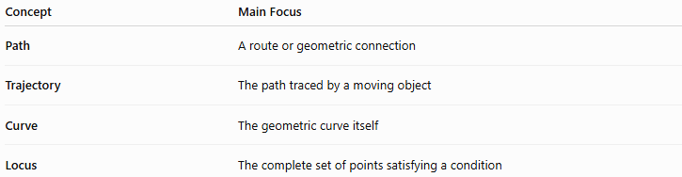
Concept | Main Focus
Path | A route or geometric connection
Trajectory | The path traced by a moving object
Curve | The geometric curve itself
Locus | The complete set of points satisfying a condition
Example
Consider:
$$P\left(t\right)=\left(\cos{t} , \sin{t}\right).$$
The curve is:
$$x^{2}+y^{2}=1.$$
The trajectory is the motion of $P\left(t\right)$around that circle.
The path is the route followed by the point.
The locus is the set:
$$\left\{\left(x , y\right):x^{2}+y^{2}=1\right\}.$$
So:
$$\boxed{\text{Curve}=\text{geometric form}} \\ \boxed{\text{Path}=\text{route}} \\ \boxed{\text{Trajectory}=\text{route traced by motion}} \\ \boxed{\text{Locus}=\text{set of satisfying points}}$$

Path vs Trajectory
# Source: AI Source: Provided by: [Data Path: Persons Table -> ID Column: 1, Name_En Column: Motasem Essam] -> From: [ChatGPT] on [7/25/2026]
The distinction can sometimes be subtle.
A path does not necessarily require physical motion. It can simply describe a route connecting points.
A trajectory normally has a moving object or point associated with it.
For example:
A curve connecting $A$and $B$is a path.
But:
The curve traced by a projectile as it moves from launch to landing is its trajectory.
Thus, trajectory is especially common in geometry, physics, mechanics, robotics, and astronomy.

Trajectory vs Locus
# Source: AI Source: Provided by: [Data Path: Persons Table -> ID Column: 1, Name_En Column: Motasem Essam] -> From: [ChatGPT] on [7/25/2026]
A trajectory and a locus can sometimes be represented by the same geometric set, but their meanings differ.
Trajectory
Focuses on motion:
$$P\left(t\right)=\left(x , \left(t\right)y\left(t\right)\right).$$
Locus
Focuses on a geometric condition:
$$F\left(x , y\right)=0.$$
For example, a satellite moving around an idealized circular orbit has a circular trajectory:
$$P\left(t\right)=\left(r , \cos{t}r\sin{t}\right).$$
The corresponding geometric locus is:
$$x^{2}+y^{2}=r^{2}.$$

Trajectory in Three Dimensions
# Source: AI Source: Provided by: [Data Path: Persons Table -> ID Column: 1, Name_En Column: Motasem Essam] -> From: [ChatGPT] on [7/25/2026]
A trajectory does not have to be two-dimensional.
In 3D:
$$\boxed{P\left(t\right)=\left(x , \left(t\right) , y\left(t\right)z\left(t\right)\right)}$$
Example
A helical trajectory can be represented by:
$$P\left(t\right)=\left(r , \cos{t} , r\sin{t}ct\right).$$
The point moves around the $z$-axis while simultaneously moving upward.
This produces a helix.
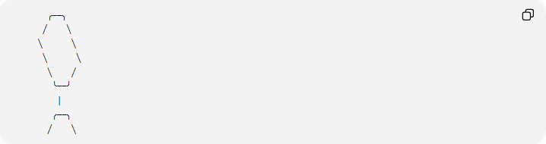
╭──╮
╱ ╲
╲ ╲
╲ ╲
╲ ╱
╰──╯
│
╭──╮
╱ ╲
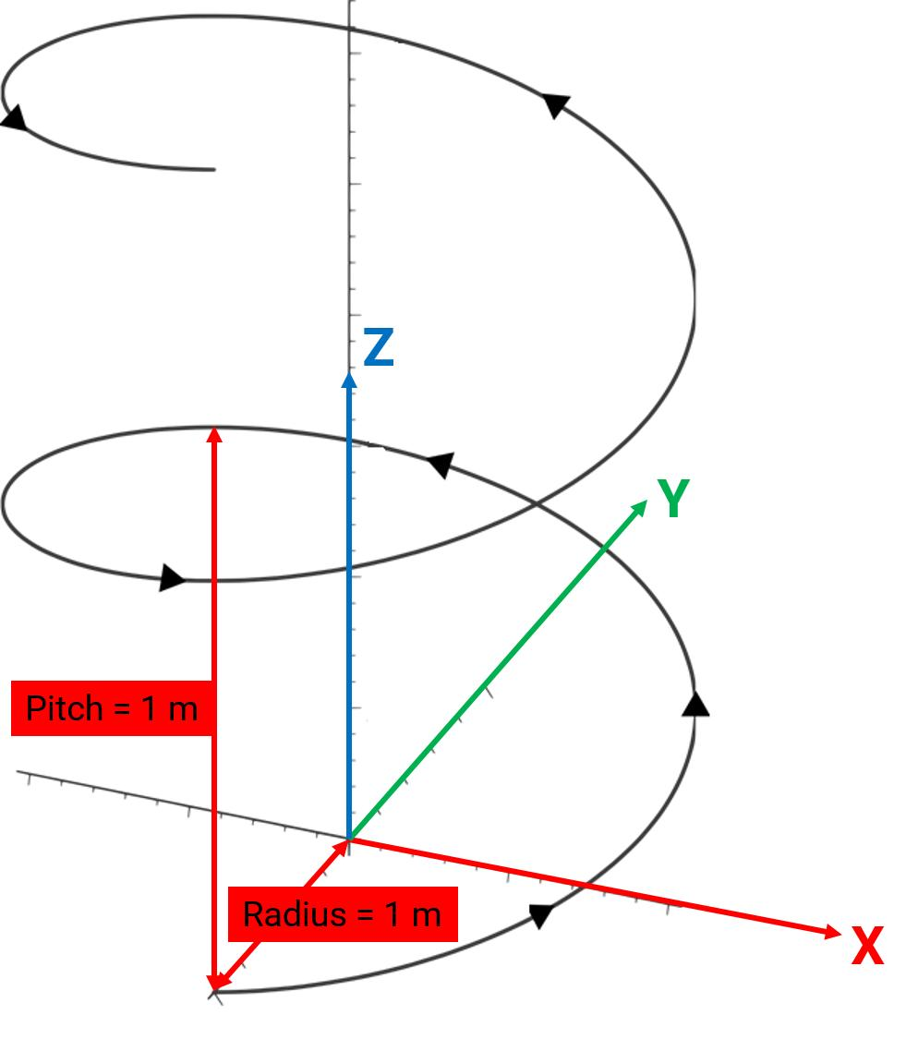
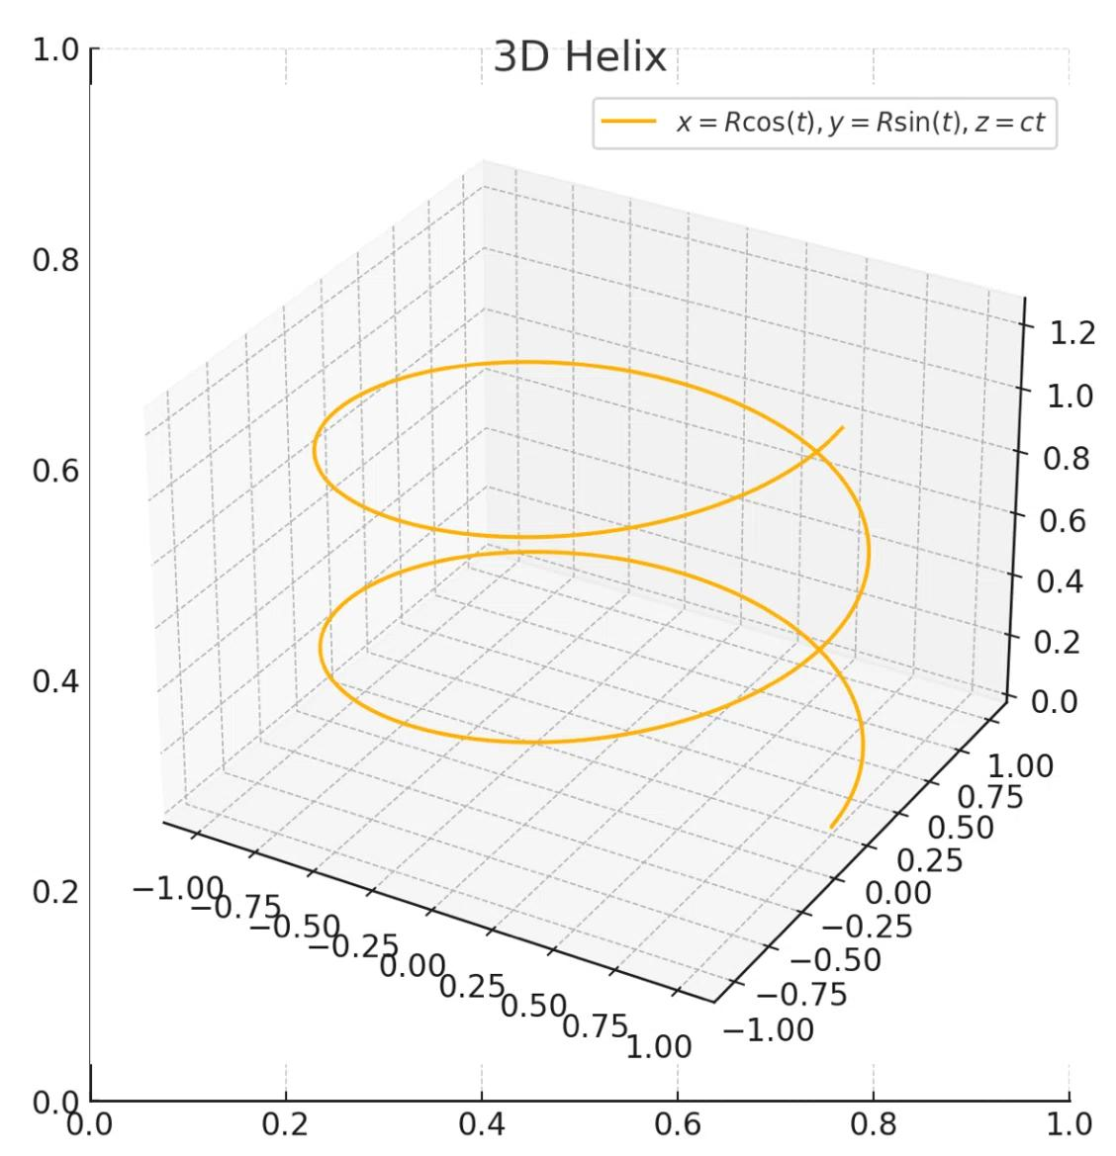
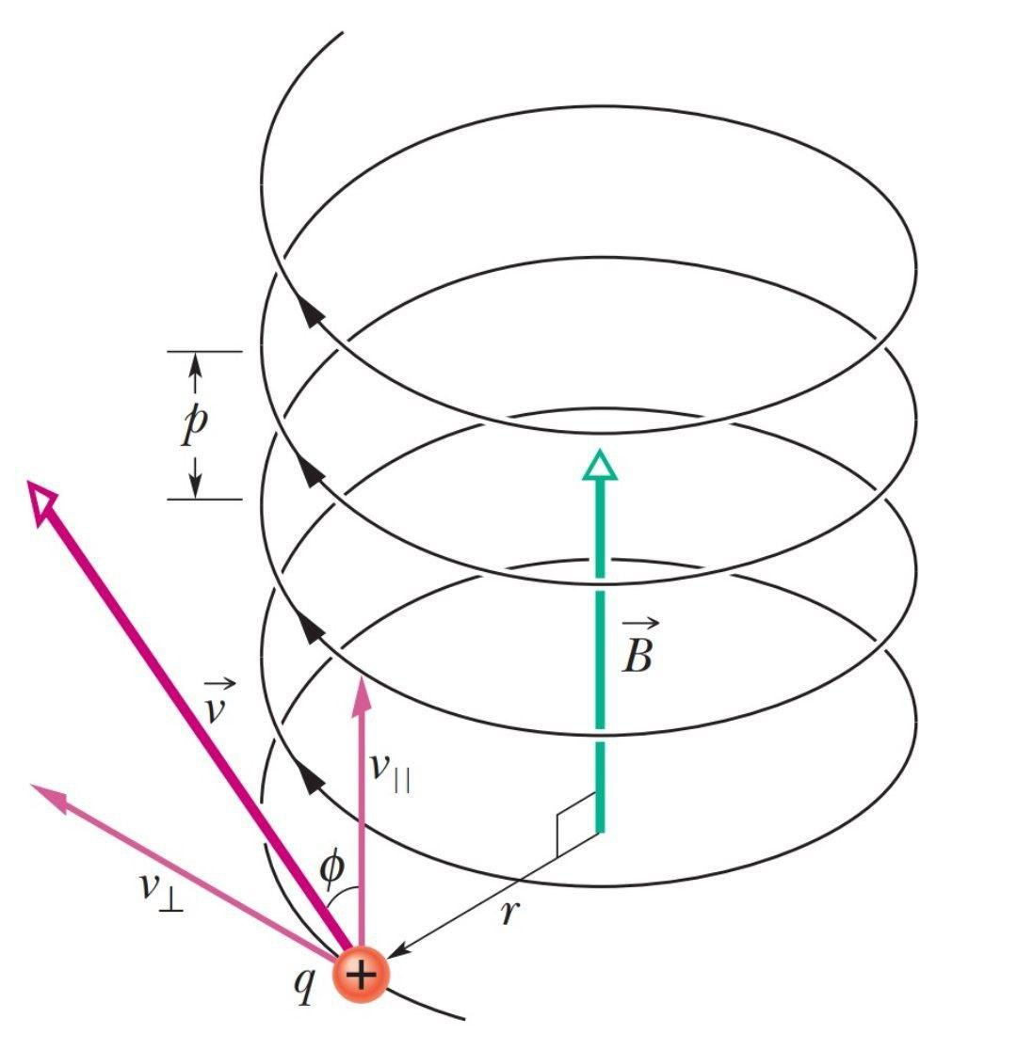
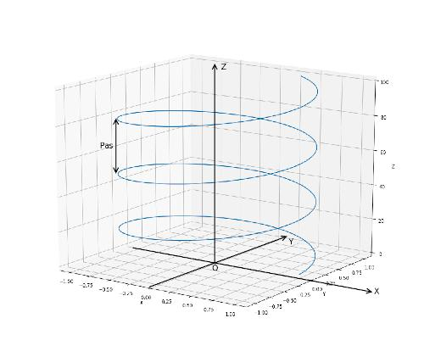
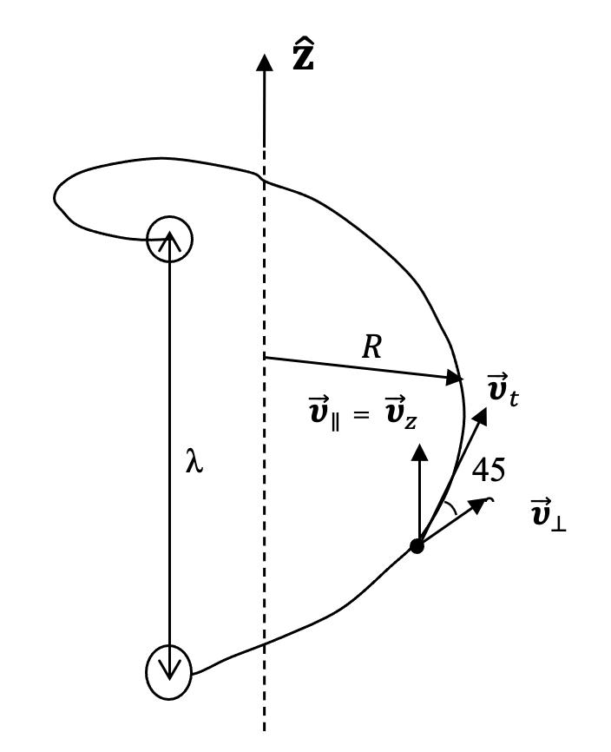

Applications of Trajectories
# Source: AI Source: Provided by: [Data Path: Persons Table -> ID Column: 1, Name_En Column: Motasem Essam] -> From: [ChatGPT] on [7/25/2026]
Trajectories are used in many areas.
Geometry
Studying curves traced by moving points.
Physics
Describing motion:
- projectiles
- particles
- planets
- satellites
Astronomy
Describing orbital paths.
Robotics
Planning the movement of a robot arm or mobile robot.
Engineering
Designing:
- roads
- tracks
- machine motion
- flight paths
Computer Graphics
Animating objects along mathematical curves.

Classification Summary
# Source: AI Source: Provided by: [Data Path: Persons Table -> ID Column: 1, Name_En Column: Motasem Essam] -> From: [ChatGPT] on [7/25/2026]
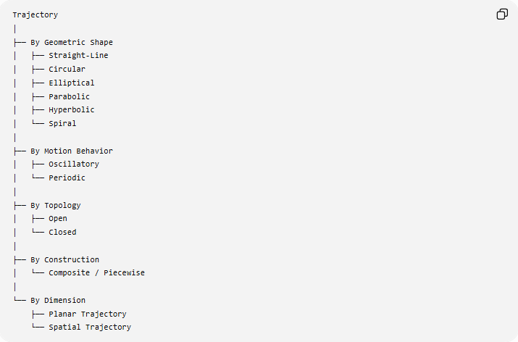
Trajectory
│
├── By Geometric Shape
│ ├── Straight-Line
│ ├── Circular
│ ├── Elliptical
│ ├── Parabolic
│ ├── Hyperbolic
│ └── Spiral
│
├── By Motion Behavior
│ ├── Oscillatory
│ └── Periodic
│
├── By Topology
│ ├── Open
│ └── Closed
│
├── By Construction
│ └── Composite / Piecewise
│
└── By Dimension
├── Planar Trajectory
└── Spatial Trajectory
This is a practical classification rather than a single universally standardized taxonomy.

Important Formulas
# Source: AI Source: Provided by: [Data Path: Persons Table -> ID Column: 1, Name_En Column: Motasem Essam] -> From: [ChatGPT] on [7/25/2026]
Position
$$\boxed{P\left(t\right)=\left(x , \left(t\right)y\left(t\right)\right)}$$
Velocity
$$\boxed{\vec{v}\left(t\right)=\frac{dP}{dt}}$$
Speed
$$\boxed{∣\vec{v}\left(t\right)∣=∣\frac{dP}{dt}∣}$$
Acceleration
$$\boxed{\vec{a}\left(t\right)=\frac{d^{2}P}{dt^{2}}}$$
Arc Length
$$\boxed{L=\int_{a}^{b}{\sqrt{{\left(x^{'}\left(t\right)\right)}^{2}+{\left(y^{'}\left(t\right)\right)}^{2}}} dt}$$
Closed Trajectory
$$\boxed{P\left(t+T\right)=P\left(t\right)}$$
for a periodic trajectory.

Key Points
# Source: AI Source: Provided by: [Data Path: Persons Table -> ID Column: 1, Name_En Column: Motasem Essam] -> From: [ChatGPT] on [7/25/2026]
- A trajectory is the path traced by a moving point or object.
- Time is commonly the parameter:
$$P\left(t\right)=\left(x , \left(t\right)y\left(t\right)\right).$$
- A trajectory may be straight, circular, elliptical, parabolic, hyperbolic, spiral, or another curve.
- Trajectories can be open or closed.
- A trajectory can be periodic when it repeats after a fixed time.
- A trajectory may exist in 2D or 3D.
- Velocity describes how position changes along the trajectory.
- Acceleration describes how velocity changes.
- The total distance traveled along a trajectory is its arc length.
- A trajectory is closely related to a path, but trajectory emphasizes motion.
- A locus emphasizes the set of points satisfying a condition, rather than the motion through them.

Conclusion
# Source: AI Source: Provided by: [Data Path: Persons Table -> ID Column: 1, Name_En Column: Motasem Essam] -> From: [ChatGPT] on [7/25/2026]
A trajectory is the geometric route traced by a moving point or object. It provides a connection between motion, time, and geometry, and can be represented using Cartesian, parametric, vector, or polar equations. Common trajectories include straight lines, circles, ellipses, parabolas, hyperbolas, and spirals. In geometry, the trajectory concept is particularly useful for understanding how curves arise from the motion of points.
Would you like a concise comparison of trajectory, path, curve, and locus?

